

Nombres: Brayan Ortiz Cundar, Luis Pérez Señalin y Jossué Rivadeneira Ordóñez

Packet Tracer - Configure Static NAT

# Objectives

**Part 1: Test Access without NAT Part 2: Configure Static NAT Part 3: Test Access with NAT**

# Scenario

In IPv4 configured networks, clients and servers use private addressing. Before packets with private addressing can cross the internet, they need to be translated to public addressing. Servers that are accessed from outside the organization are usually assigned both a public and a private static IP address. In this activity, you will configure static NAT so that outside devices can access an inside server at its public address.

# Instructions

**Part 1: Test Access without NAT**

## Step 1: Attempt to connect to Server1 using Simulation Mode.

1. Switch to Simulation mode.
2. From **PC1** or **L1**, use the Web Browser to attempt to connect to the **Server1** web page at 172.16.16.1. Continue to click the **Capture Forward** button, notice how the packets never leave the internet cloud. The attempts should fail.

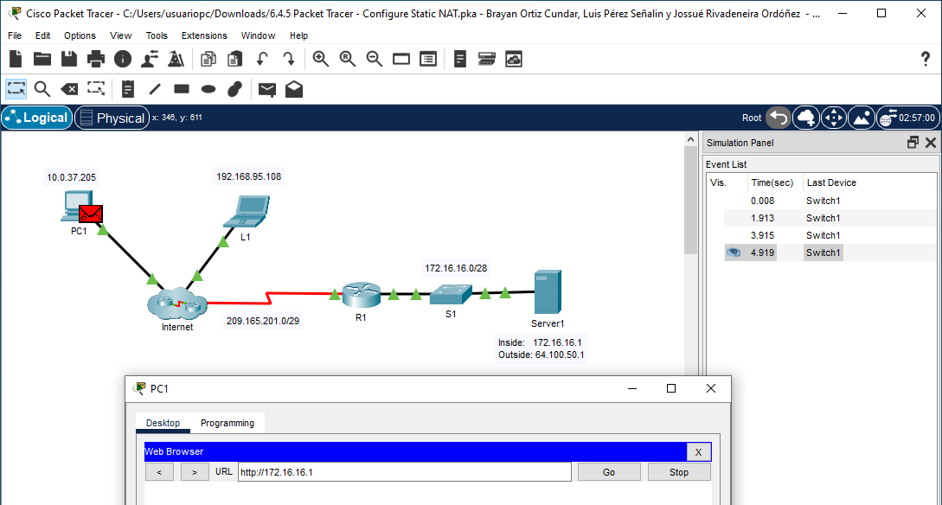

1. Exit **Simulation** mode.
2. From **PC1**, ping the **R1** S0/0/0 interface (209.165.201.2). The ping should succeed.

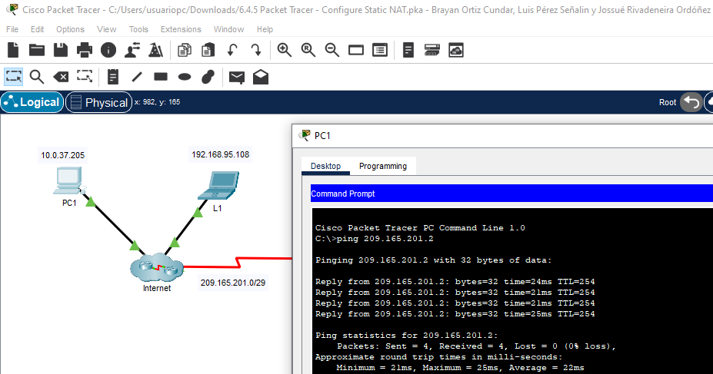

## Step 2: View R1 routing table and running-config.

1. View the running configuration of **R1**. Note that there are no commands referring to NAT. An easy way to confirm this is to issue the following command:

R1# **show run | include nat**

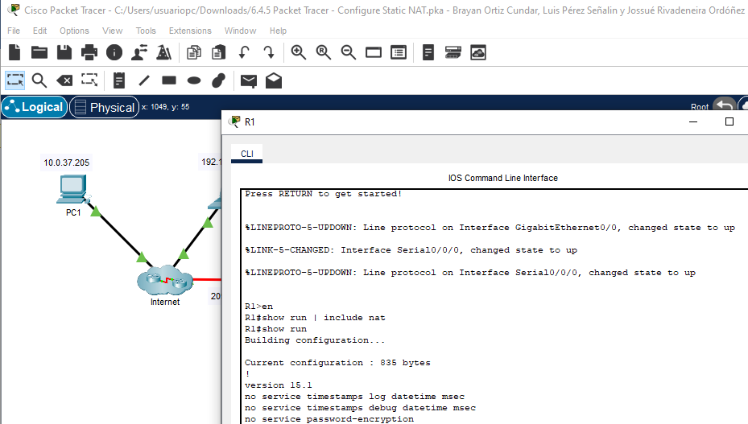

1. Verify that the routing table does not contain entries referring to the IP network addresses for **PC1** and

**L1**.

1. Verify that NAT is not being used by **R1**.

R1# **show ip nat translations**

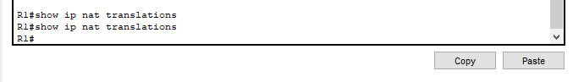

# Part 2: Configure Static NAT

## Step 1: Configure static NAT statements.

Refer to the Topology. Create a static NAT translation to map the **Server1** inside address to its outside address.

R1(config)# **ip nat inside source static 172.16.16.1 64.100.50.1**

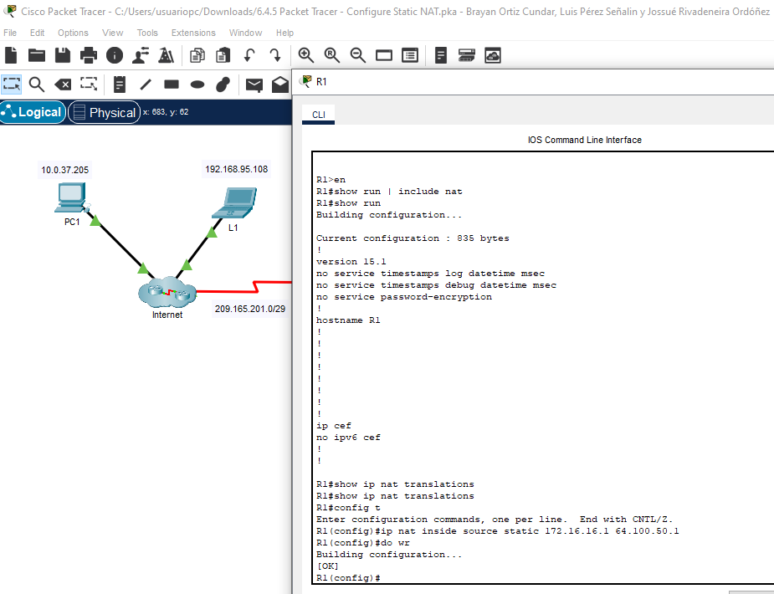

**Packet Tracer - Configure Static NAT**

## Step 2: Configure interfaces.

1. Configure the **G0/0** interface as an inside interface.

R1(config)# **interface g0/0**

R1(config-if)# **ip nat inside**

1. Configure the s0/0/0 public interface as an outside interface.

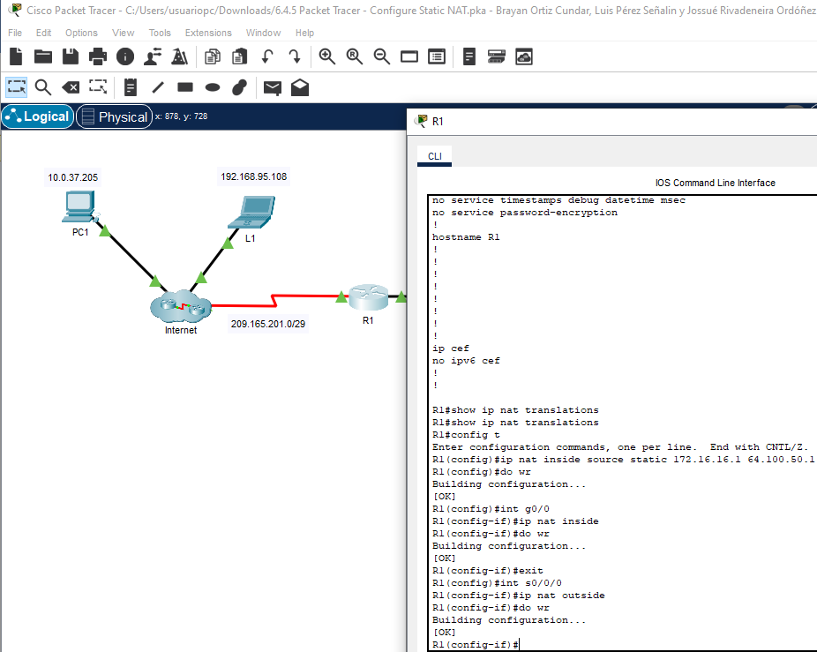

# Part 3: Test Access with NAT

## Step 1: Verify connectivity to the Server1 web page.

1. Open the command prompt on **PC1** or **L1**, attempt to ping the public address for **Server1**. Pings should succeed.

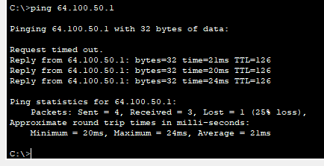

1. Verify that both **PC1** and **L1** can now access the **Server1** web page.

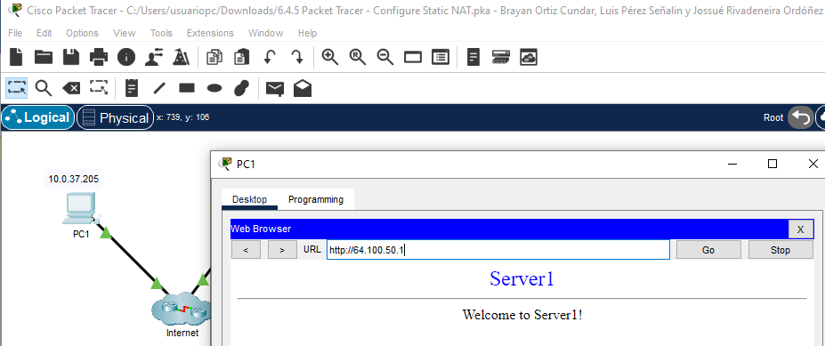

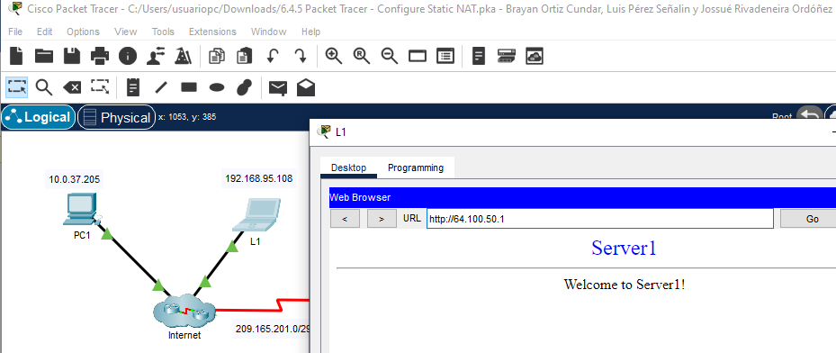

## Step 2: View NAT translations.

Use the following commands to verify the static NAT configuration on **R1**:

**show running-config**

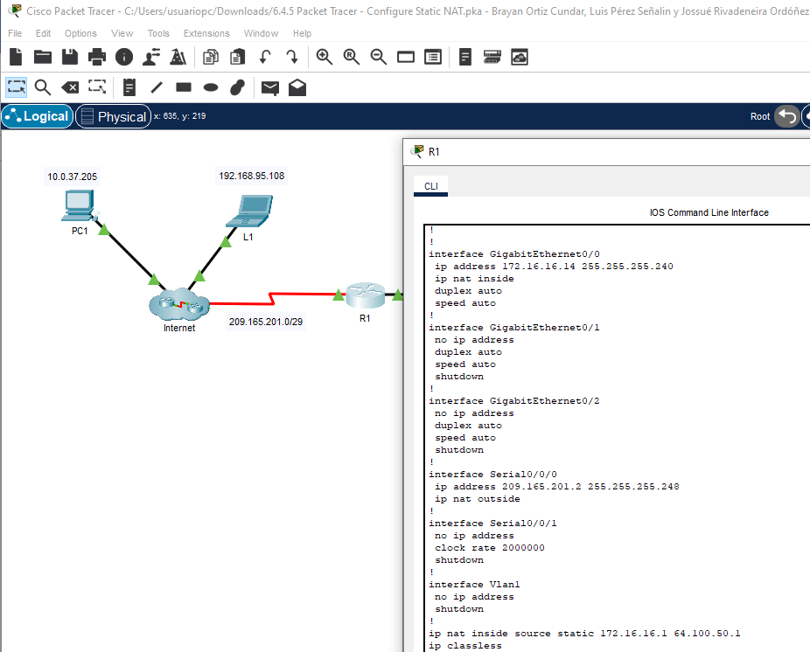

**show ip nat translations**

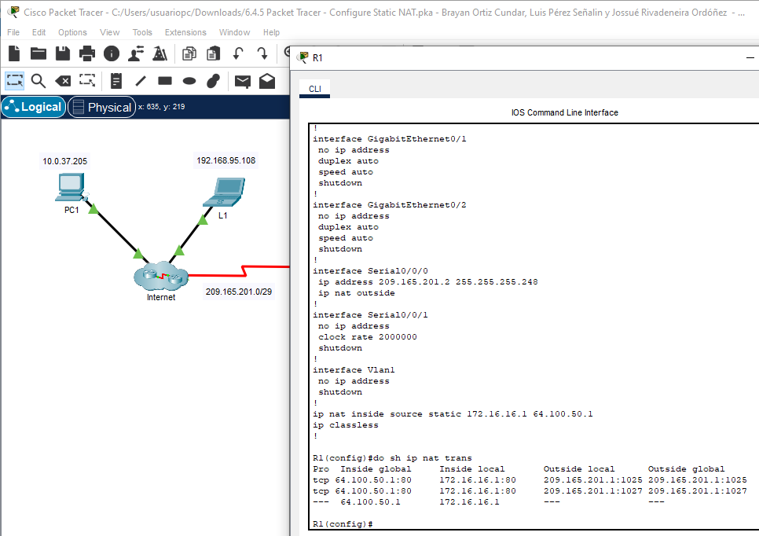

**show ip nat statistics**

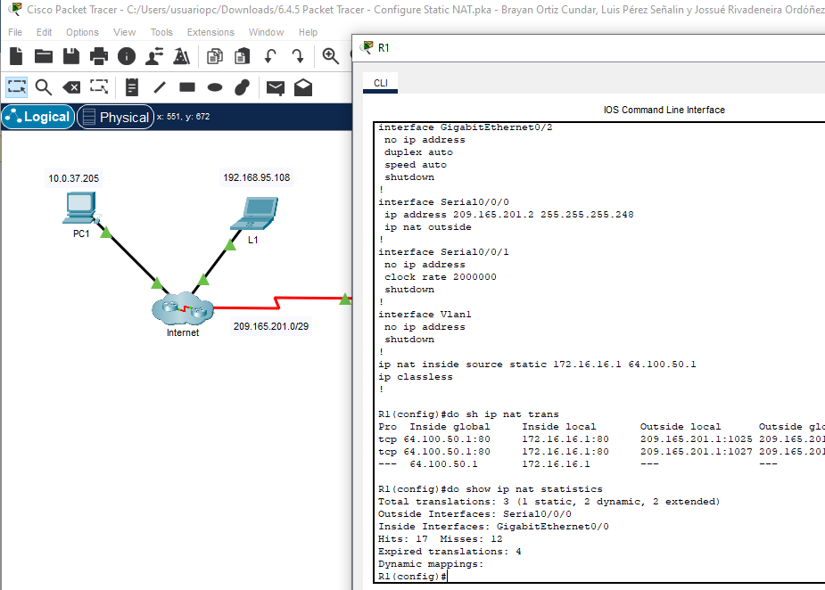

Verificación:

